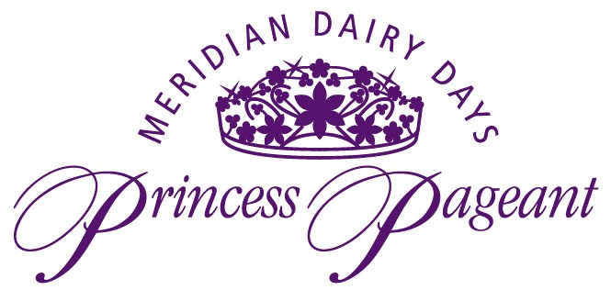
Meridian Dairy Board
2024 Dairy Princess Application (Age 15-17)
2024 Junior Dairy Princess Application (Age 13-14)
Please see the important application information below.

The Meridian Dairy Days Princess Pageant is an opportunity for girls throughout the Treasure Valley to compete for the title of Dairy Princess or Junior Princess. The Meridian Dairy Board seeks to promote an awareness of the positive effects of the dairy industry in our communities. The purpose of this pageant is to encourage a desire for community involvement in today’s youth, and to teach tomorrow’s women leaders necessary skills such as poise, self-worth, and public speaking.

Applicants must meet the following qualifications:
- 15-17 years of age by June 19, 2024 for Meridian Dairy Princess
- 13-14 years of age by June 19, 2024 for Junior Dairy Princess
- A dairy consumer or live or work on a dairy farm, or show livestock in open FFA or 4-H.
- Be able to represent the Treasure Valley Dairy Industry in a positive manner including public appearances, and educational programs.
- Must NOT be a graduating senior.

Application Rules:
- Applications will not be accepted any earlier than 12:01pm on April 20, 2024.
- The deadline to turn in applications is April 27th.
- If more than 12 applications are received, we reserve the right to possibly have an essay run-off contest.
- The Meridian Dairy Princess Chairs also reserve the right to alter the age brackets as needed.
- Please return applications to: dairydaysprincess@yahoo.com

Orientation: Saturday, May 4th Time and Place TBD
Group and Individual Photos: May 30th Time and Place TBD
Pageant Night: Wednesday, June 19th
Pageant activities will take place the week of June 19th-June 22nd

If you have any questions please feel free to contact us at: dairydaysprincess@yahoo.com or Sharlie 208-871-7651, Jenny 208-590-4680, or Lisa 208-863-7859.

Meridian Dairy Board
2024 Dairy Princess Application (Age 15-17)
2024 Junior Princess Application (Age 13-14)
Applications will NOT be accepted before 12:01pm on April 20th

Name: ___________________________________________

Parent’s Phone: ________________________ Your Phone:_____________________

Do you prefer a phone call or a text if we need to get a hold of you: ________________

Your Email:__________________________________________________________________

Parent’s Email:______________________________________________________________

Address: __________________________________________________________________

I am applying for:

Junior Princess: _______________ Meridian Dairy Princess:________________

Age: ________ Date of Birth: _______________ Year in School:___________

Name of School you are attending: _____________________________________________

Legal Guardian’s Name:________________________________________________________

Please answer the following questions on a separate sheet of paper and attach it to the application. Please keep answers to 200 words or less.

- Tell us about yourself. Please include hobbies, interests, service projects, community affiliations, etc.

- List 2 ways you would inform and promote dairy products and the dairy industry if you were chosen as Dairy Princess or Junior Princess. Please be specific.

- There is a lot of talk lately about dairy products versus plant-based alternatives. Please tell us how you would convince your best friends why dairy products are the way to go. (Jr. Princess Only)

- According to Idaho’s Dairymen’s Association, 2024 will be the first time in a long-time milk production growth will come to a halt in Idaho. What is causing this and is there anything that you can think of to help the dairymen in Idaho? (Sr. Princess Only)

