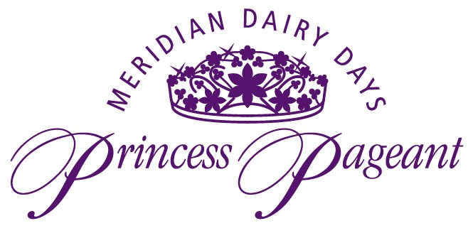

**Meridian Dairy Board**

**2025 Dairy Princess Application (Age 15-17)**

**2025 Junior Dairy Princess Application (Age 13-14)**

***Please see the important application information below.***

The Meridian Dairy Days Princess Pageant is an opportunity for girls throughout the Treasure Valley to compete for the title of Dairy Princess or Junior Princess. The Meridian Dairy Board seeks to promote an awareness of the positive effects of the dairy industry in our communities. The purpose of this pageant is to encourage a desire for community involvement in today’s youth, and to teach tomorrow’s women leaders necessary skills such as poise, self-worth, and public speaking.

Applicants must meet the following qualifications:

1. 15-17 years of age by June 18, 2025 for Meridian Dairy Princess
2. 13-14 years of age by June 18, 2025 for Junior Dairy Princess
3. A dairy consumer or live or work on a dairy farm, or show livestock in open FFA or 4-H.
4. Be able to represent the Treasure Valley Dairy Industry in a positive manner including public appearances, and educational programs.
5. Must NOT be a graduating senior.

Application Rules:

* **We will only be accepting the first 14 contestants this year. Applications will be accepted based on time-stamped emails.**
* Applications **will not be accepted** any earlier than 12:01pm on April 12, 2025.
* The deadline to turn in applications is April 19th.
* The Meridian Dairy Princess Chairs also reserve the right to alter the age brackets as needed.
* Please return applications to: dairydaysprincess@yahoo.com

**Orientation:** Saturday, May 10th Time and Place TBD

**Group and Individual Photos**: May 27th Time and Place TBD

**Pageant Night:** Wednesday, June 18th

**Pageant activities** will take place the week of June 18th-June 21st

If you have any questions, please feel free to contact us at: dairydaysprincess@yahoo.com or Sharlie 208-871-7651, Jenny 208-590-4680, or Lisa 208-863-7859.



Meridian Dairy Board

2025 Dairy Princess Application (Age 15-17)

2025 Junior Princess Application (Age 13-14)

***Applications will NOT be accepted before 12:01pm on April 12th***

Name: ___________________________________________

Parent’s Phone: ________________________ Your Phone:_____________________

Do you prefer a phone call or a text if we need to get a hold of you: ________________

Your Email:__________________________________________________________________

Parent’s Email:______________________________________________________________

Address: __________________________________________________________________

**I am applying for:**

Junior Princess: _______________ Meridian Dairy Princess:________________

Age: ________ Date of Birth: _______________ Year in School:___________

Name of School you are attending: _____________________________________________

Legal Guardian’s Name:________________________________________________________

Please answer the following questions on a separate sheet of paper and attach it to the application. Please keep answers to 200 words or less.

1. Tell us about yourself. Please include hobbies, interests, service projects, community affiliations, etc.

1. List 2 ways you would inform and promote dairy products and the dairy industry if you were chosen as Dairy Princess or Junior Princess. Please be specific.

1. **How will the bird flu outbreak affect dairy farms in Idaho and their operations?** (Jr. Princess Only)
2. What implications will the new tariffs have on agriculture and how should dairy farmers prepare for these implications? (Sr. Princess Only)